**Shi’r** شعر **(‘Poetry’)**

Mark D. Luce

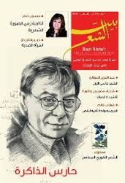

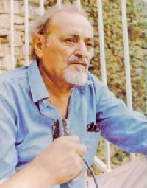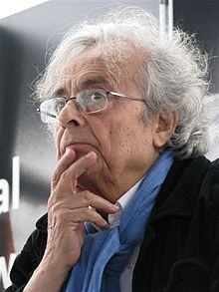

Yūsuf al-Khāl Adunis (‘Ali Ahmad Said)

The journal, *Shi’r* (*Poetry* 1957-70) was established in Beirut by Yūsuf al-Khāl and the poet theorist Adunis to save poetry from politics. It emerged as a professional avant-garde monthly journal with a core group of young poets dedicated to poetry and poetic studies. The journal supported poetic experimentation. *Shi’r* advocated for the prose poem as away to spark cultural change, believing that innovative efforts were necessary to intellectually modernize the Arab World.

*Shi’r* rebelled against the ‘committed literature’ (al-adab al-multazim) movement of the 1950s and 1960s. The circle believed this to be ‘a prostitution of art’ to political causes and ideologies. *Shi’r* was perceived as a subversive cultural movement. It was banned in a number of countries, accused of supporting a culture-war against Arab nationalism, and of being funded by the CIA and French intelligence and others.

*Shi’r’s* poets were more concerned with the post-colonial Arab ‘state of being’ than reforming or overthrowing states. The *Shi’r* poets adopted the concept of *ru’iya* or vision theorized in 1959 by Adunis (‘Ali Ahmad Said) who asserted that modern poetry possessed a mystical or intuitive knowledge that allowed the poet to see beyond. The intention was to liberate Arab consciousness and to liberate it from the *qasidah* using the Arabic language, to free one’s thinking.

**Clash / Rivalry with al-Adab**

When Yusuf al-Khal founded *Shi’r* in January of 1957 in Beirut, the weekly Arab literary

journal *al-Adab* (est. 1953) reigned supreme on the avant-garde literary scene. It touted the Jean Paul Sartre existential line of political ‘commitment literature’ (adab al-iltizam), arguing that literature must contribute to societal change. It declared that there could no longer be ‘art for art’s sake.’

*Al-Adab* with its ‘commitment literature’ dedicated to social and political causes became the literary springboard for Arab Nationalists and Marxists along with Socialist Realism. Their writers and poet contributors created a forum to debate what genre of literature - the novel, the short story, the realist, or the absurdist was the capable of changing society.

By contrast, all of the *Shi’r* poets believed that all poetry was inherently committed and that all literature could change the world. Nadhir al-‘Azma, contrasted the *Shi’r* circle of poets as ‘committed to transforming politics to poetry, not poetry to politics.’ Al-‘Azma and al-Khāl with their concept of a ‘poetic politics of liberation’ declared that it abolished the traditional classical structures of Arab poetry and the *qasidah*, liberating the poet’s words from the constraints of rhyme, monorhythm, and meter.

The *Shi’r* poets dealt with the question of the di-glossia between literary and colloquial Arabic, and gave it precedence over the question of words and meaning. They believed that language in poetry was not a means of expression but of creation. So, they expected words to suggest and inspire rather than express. Additionally, because their new poetry had mystical tendencies, they strived to delve deeply into the meaning of the universe.

Further Reading:

Giordani, Angela. ‘Poetic Dissent: Shi’r’s Challenge To The Post-Colonial Arab State,’ MESA 2013 presentation

[Haidar](http://www.amazon.com/Otared-Haidar/e/B001TPXESU/ref=dp_byline_cont_book_1), Otared. *The Prose Poem and the Journal Shi'r: A Comparative Study of Literature, Literary Theory and Journalism*, (Ithaca Press 2008).

Jayyusi, S.Kh. *Trends and movements in modern Arabic poetry*, (Leiden 1977), 1:46.

Moreh,S. *Modern Arabic poetry 1800-1970*, *the development of its forms and themes under the influence of Western literature*, Leiden 1976